**Transfer Learning With Tensorflow**

Practice of Artificial Intelegence

Name : 劉泰佑

Id : C100E030

1. Import all the required libraries

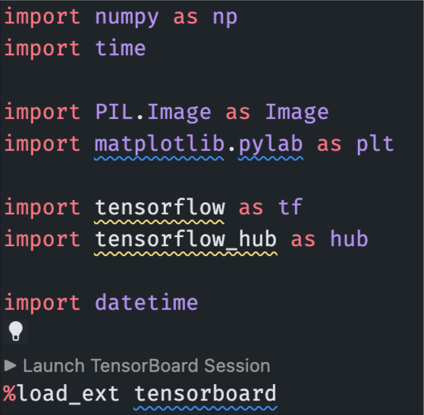

1. Download pre-trained model

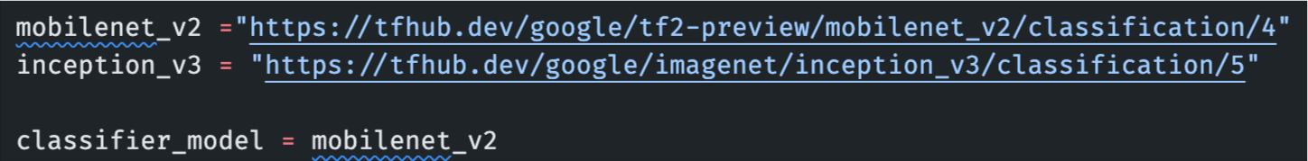

1. Try running on single image

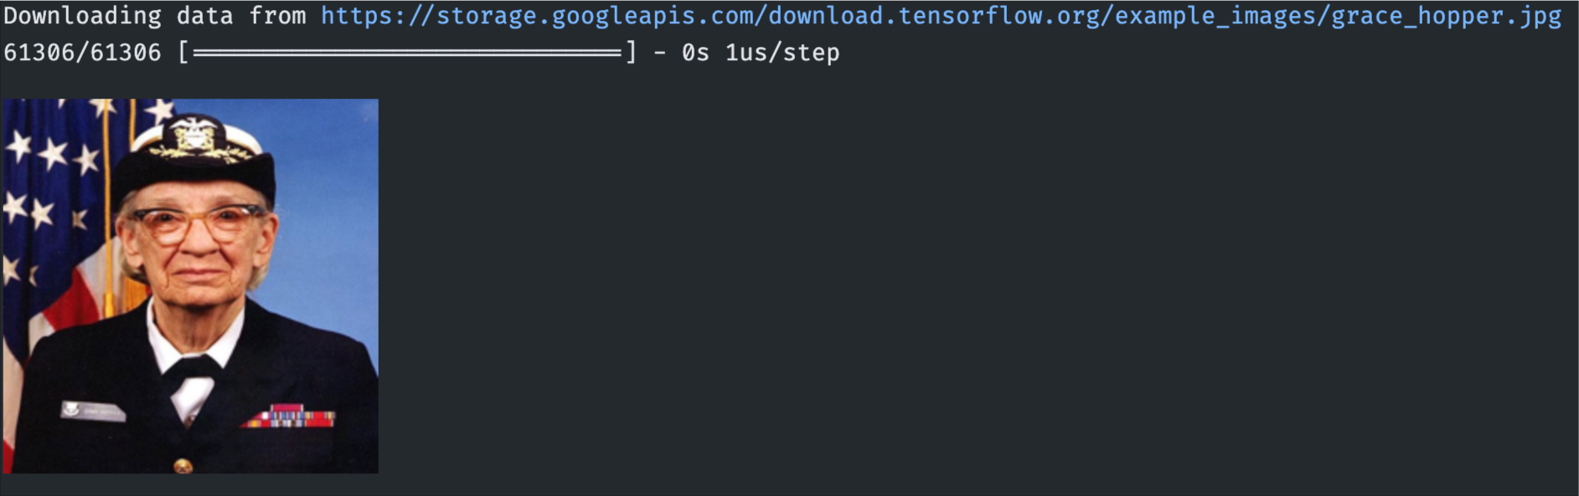

1. Prediction

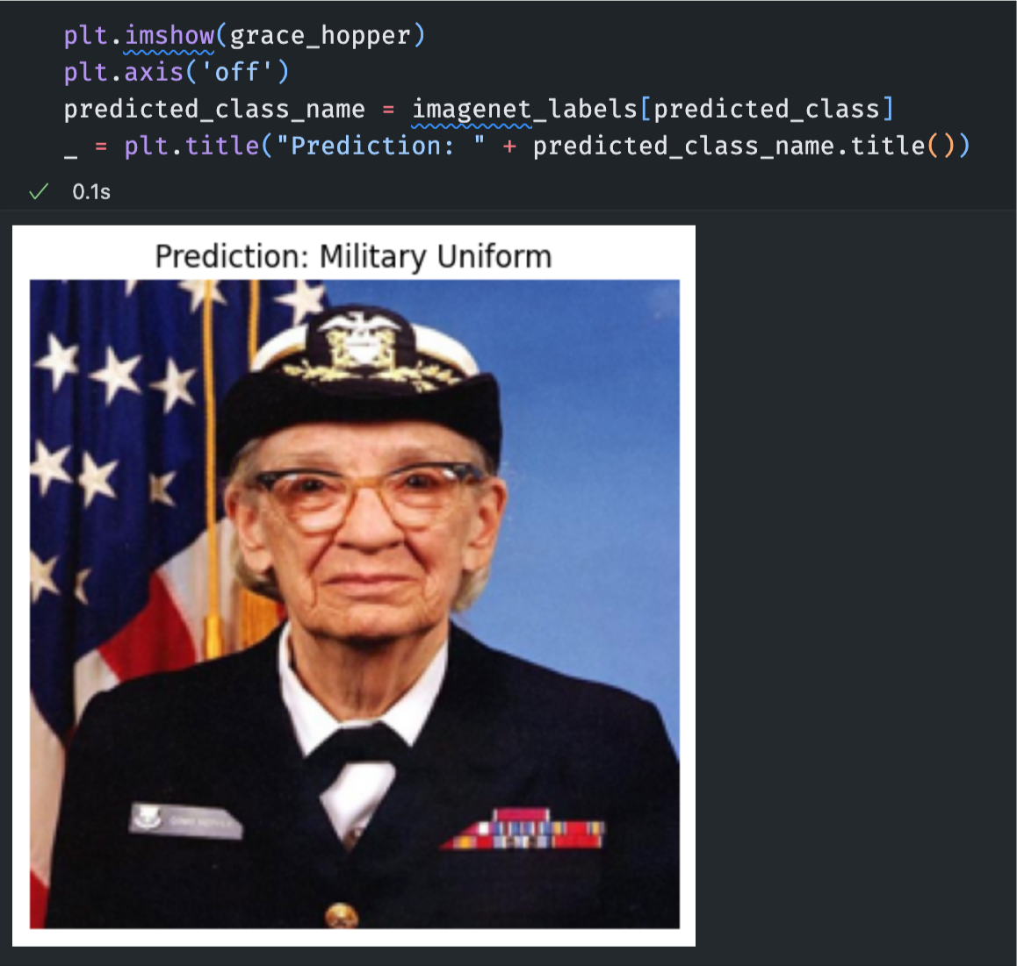

1. Simple transfer learning: download flower dataset

1. Classes

1. First imageNet prediction

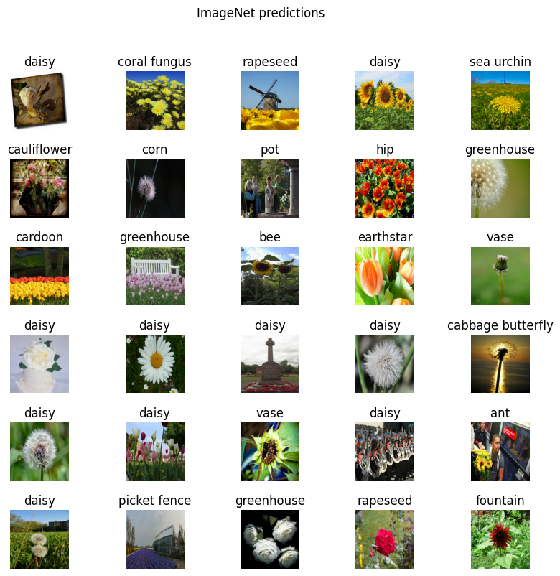

1. Try using the headless model: re-download the pre-trained models

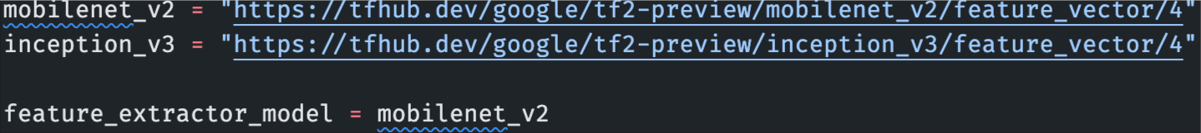

1. Attach the classification head

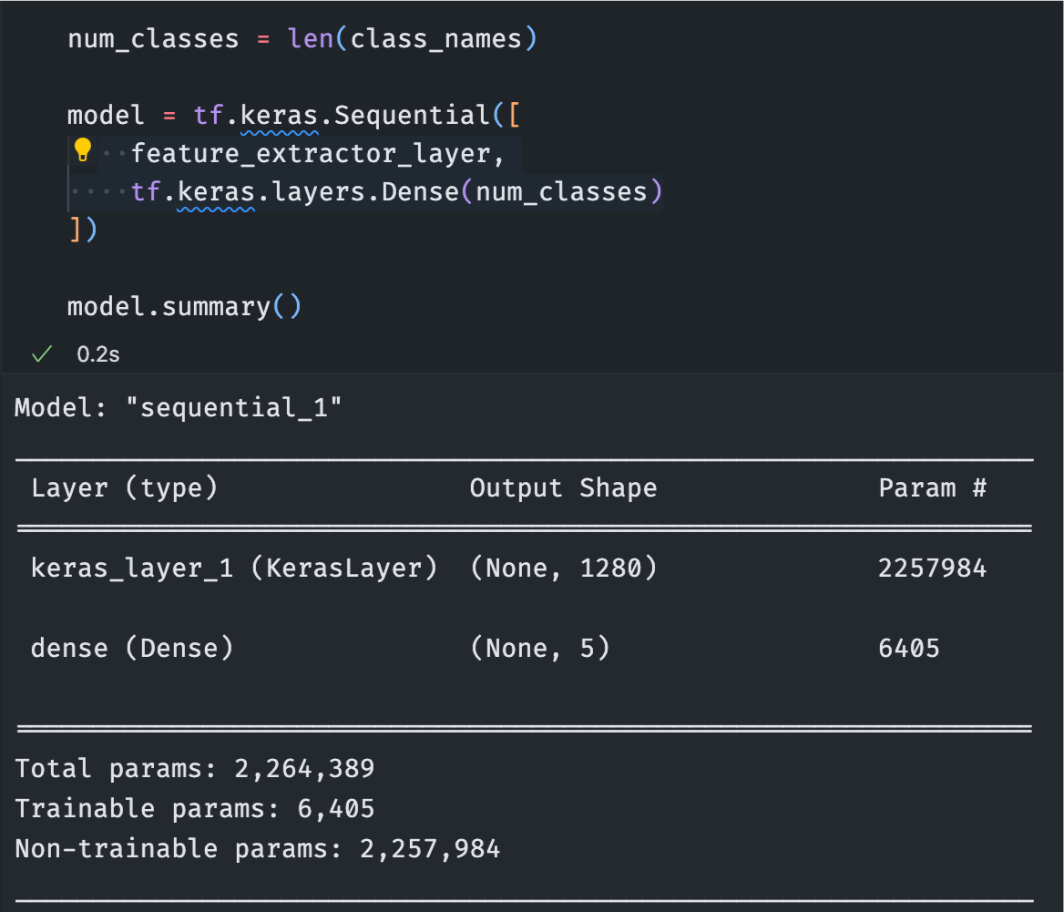

1. Model training

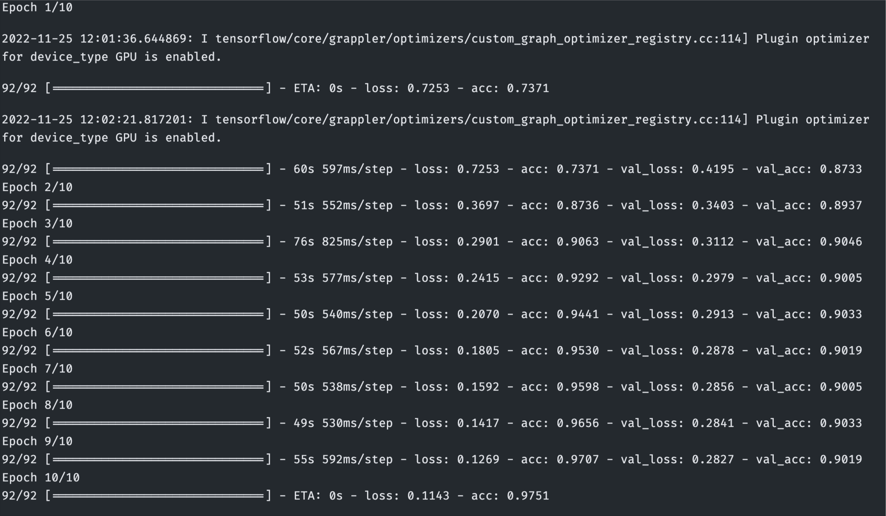

1. Check the predictions

1. Plot the model prediction

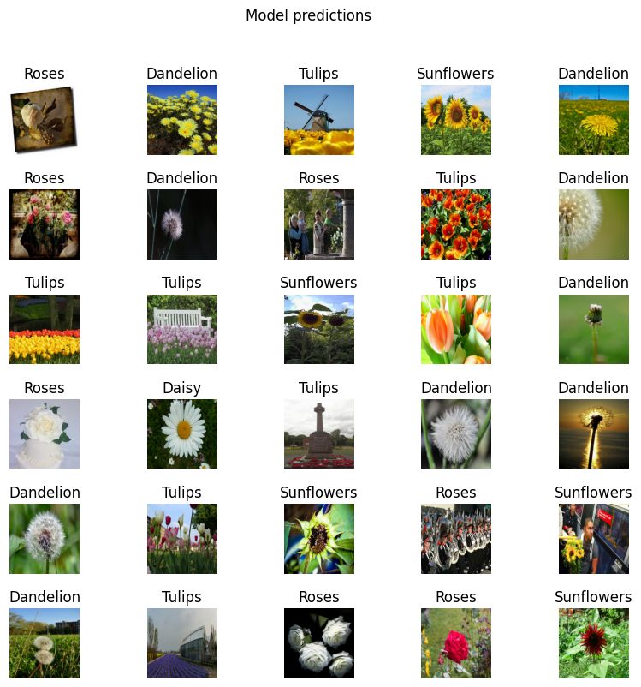

1. Export and reload model

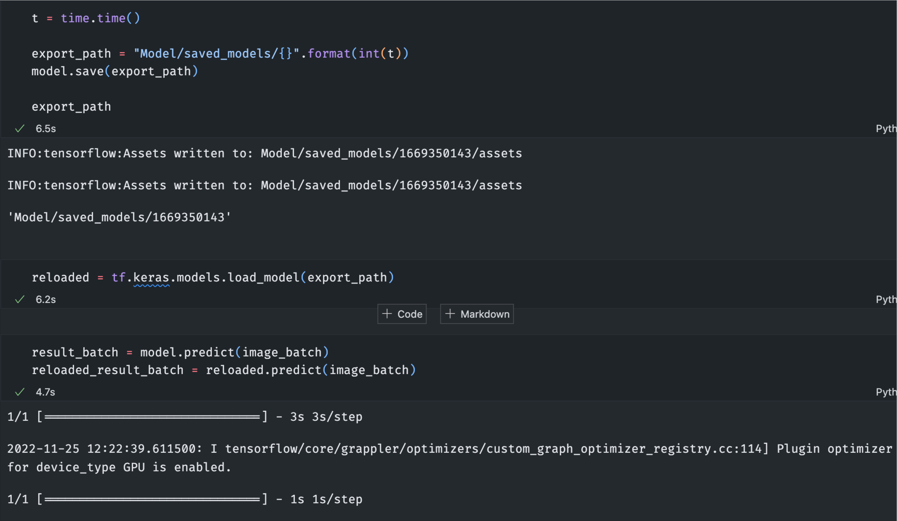

1. Re-run the predictions

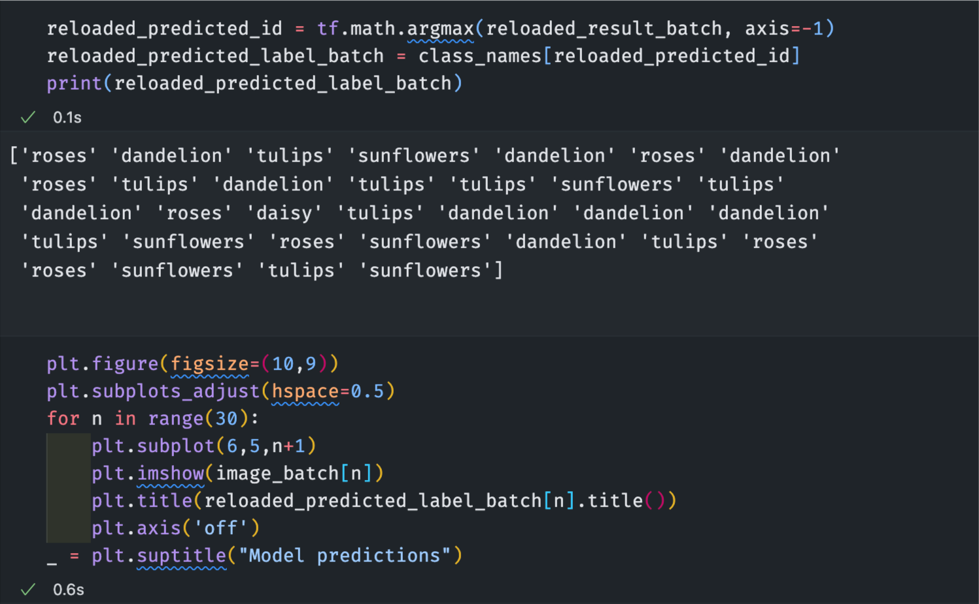

1. Final results

